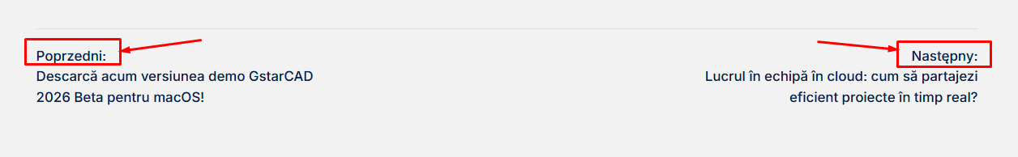
And at the end of every article change Poprzedni: to Anterior and Następny: to Următorul

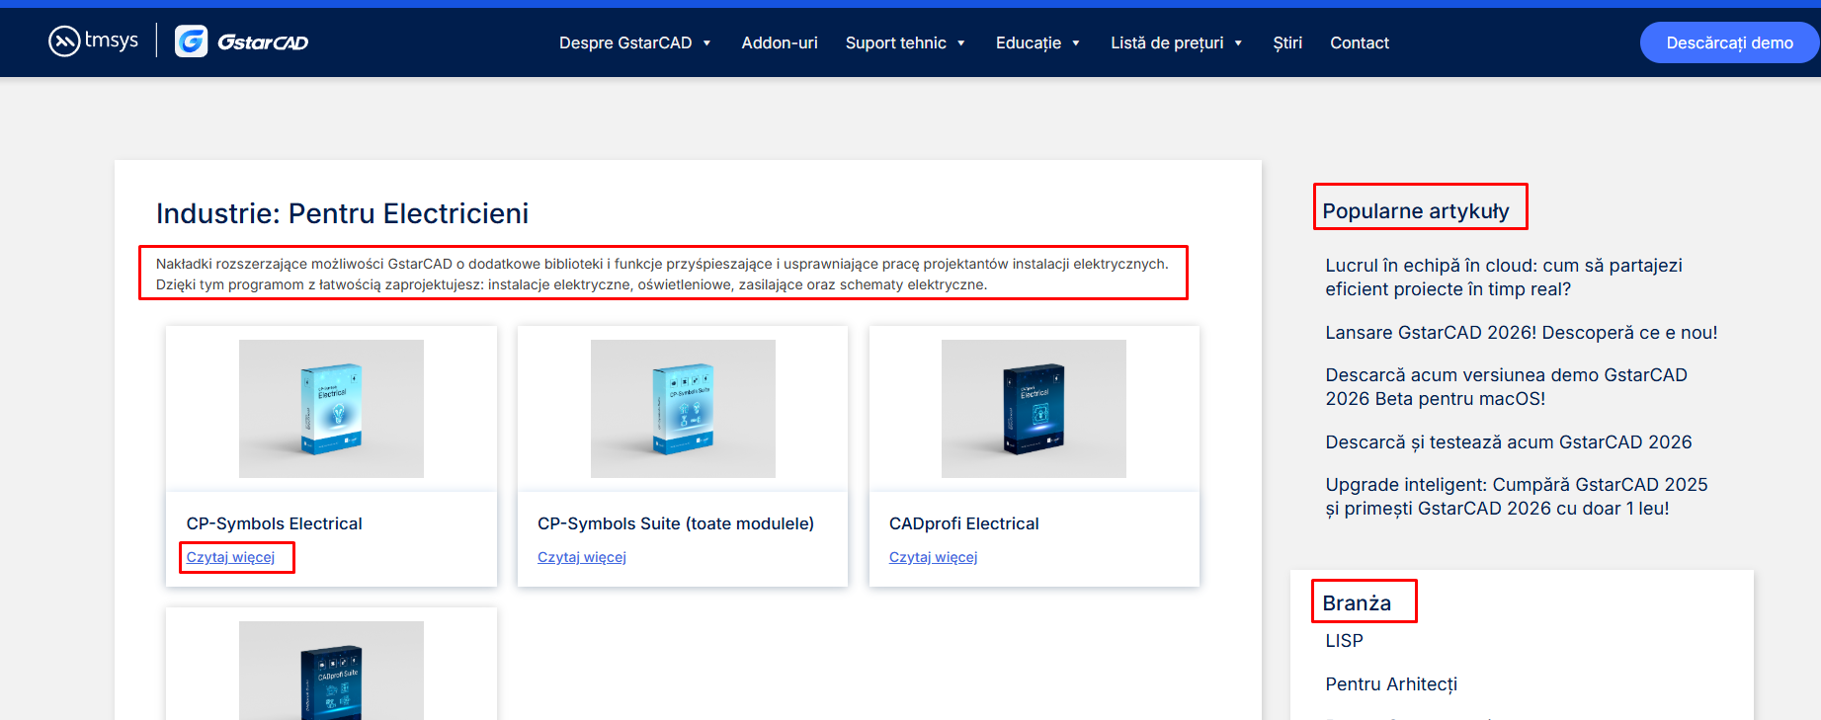
On this change Branza to Industrie and Czytaj więcej to Citește mai mult
https://gstarcad.com.ro/branza/dla-elektrykow/
https://gstarcad.com.ro/branza/dla-architektow/
https://gstarcad.com.ro/branza/dla-mechanikow/
https://gstarcad.com.ro/branza/dla-instalatorow/
https://gstarcad.com.ro/branza/pentru-constructori/
https://gstarcad.com.ro/branza/dla-geodetow/
For this pages.
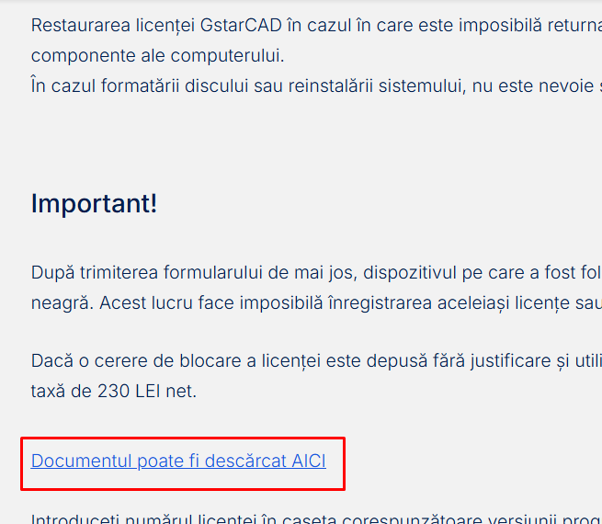
https://gstarcad.com.ro/odnowienie-licencji/ here change the document on this link for this one: https://we.tl/t-m3oxOHHytm

